Future work:  
1) Real Estate value prediction based on GDP, Unemployment Rate, Per capita Income.

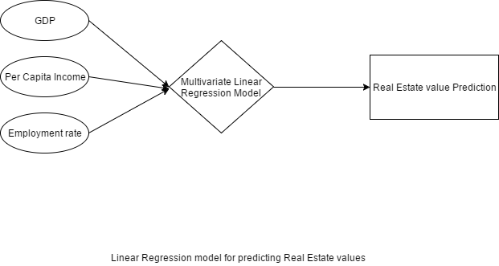

1. After applying multivariate linear regression on the data, It is observed that the Real estate price of the city depends heavily on the GDP, Unemployment Rate, Per capita Income.
2. We were able to build model using GDP, Unemployment Rate, Per capita Income and predict the real estate prices with standard variance ranging from 2390-4598 with 8 degrees of freedom
3. This results are significant enough to conclude the dependency of Real Estate value based on GDP, Unemployment Rate and Per capita Income

